**Question 1:** What are three conclusions we can make about Kickstarter campaigns given the provided data?

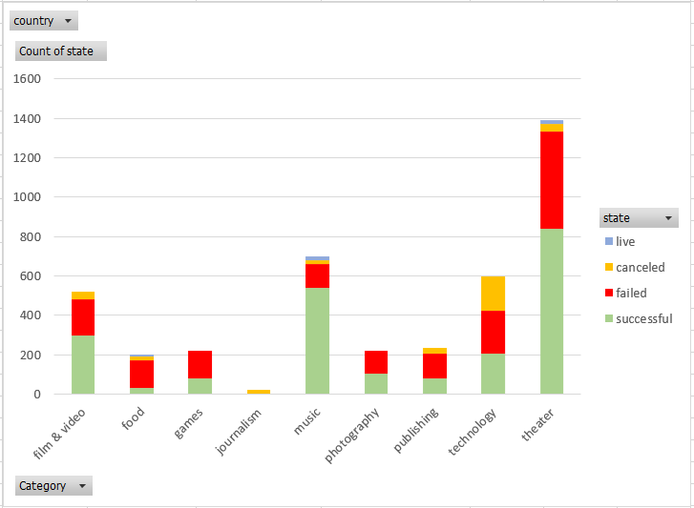

Out of the 6 categories, theater has the highest number of successful projects and follow by music.

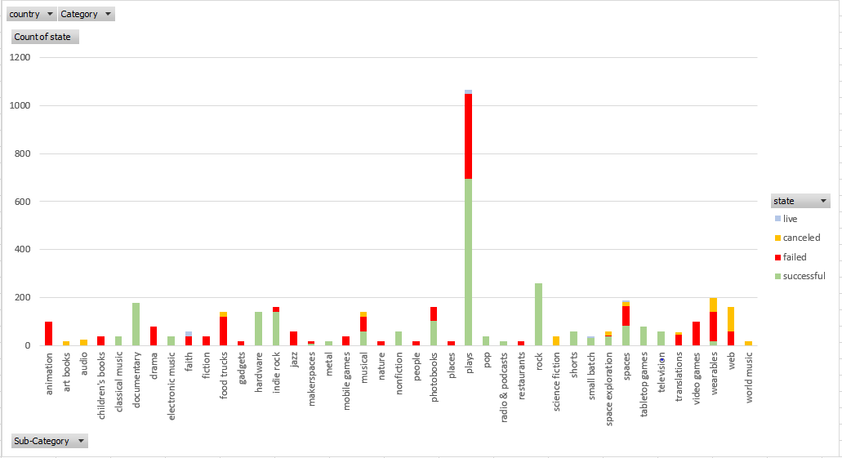

Sub-categories Plays is the main contributor to the successful of theater category. Its number of successful projects is significantly higher than any other sub-categories.

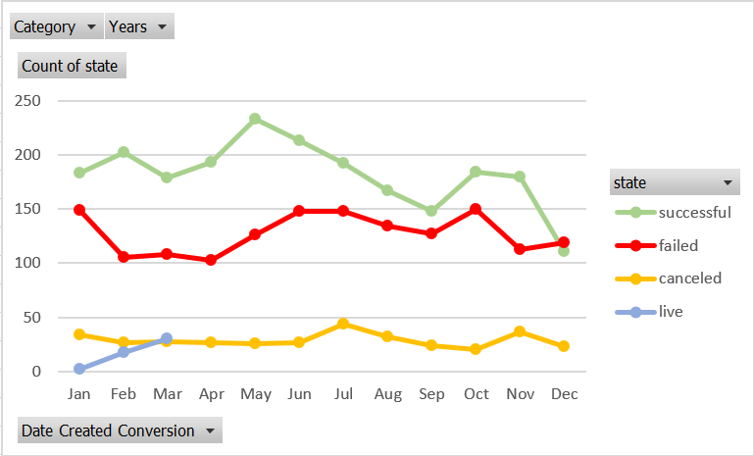

Project owner should avoid launching new project in November and December to improve its chance of reaching required funding.

**Question 2:** What are some of the limitations of this dataset?

* The size of the data might not big enough. We are looking at only 4,000 past projects while the number of projects on Kickstarter is more than 300,000.
* We don’t consider other factors that might contribute to the successful of project’s funding, such as marketing activities of the projects on social media and reputation of project owners

**Question 3:** What are some other possible tables/graphs that we could create?

* Graph showing the number of backers per category
* Graph showing the average donation of each backers per category
* Graph showing on average how many dates it takes for a project to receive its funding goal
* Graph showing successful percentage of project by country